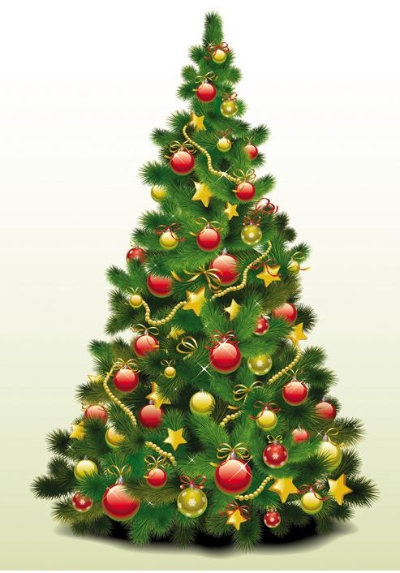****

**The Community Love Light Tree is made possible by**

**Joy and Greg Smith**

*Your tax-deductible donation will not only honor your loved ones and decorate the tree, but will also contribute to the many ministries of St. Stephen’s United Methodist Church.*

.

**St. Stephen’s United Methodist Church**  
101 E. State Street  
Delmar, DE 19940

(302) 846-9501

[**www.ststephensumc.com**](http://www.ststephensumc.com)

**2018 Holiday Season**

Like our facebook page

**Community Love Light Tree**

**Community**

**Love Light Tree**

**Community**

**Love Light Tree**

ORDER FORM SIDE 2

**Thank you   
for your support!**

Mail payment and order form to:  
St. Stephen’s UMC (address on back)

**A minimum of $5 per person is requested.**

***Larger gifts are welcome!***

***Light colors and their significance:***

* **White - in memory of someone who has passed**
* **Green – in honor of   
  someone still living**
* **Red - Fire Fighter(s)**
* **Blue - Police Officer(s)**
* **Yellow – Military**
* **Orange– Pet(s)**
* **Lavender – Cancer Awareness**
* **Pink – Breast Cancer Awareness**

Honorees Name(s):

Name 1

Light color:

Name 2

Light color:

Name 3

Light color:

(You may attach an additional sheet   
of paper for more names.)

**6th Annual**

**The Community Love Light Tree is made possible by…**

Sun Belt – George Barnhouser

The Metal Shop

In Memory of Fred Disharoon

Bryan & Brittingham

Atlantic Coastal Well Drilling

David Brown, Sussex Irrigation

Holloway Funeral Home

Holloway Pet Cremation Services

Eastern Shore Cremation & Funeral Ser.

Banner Donated by Pam Price

Tim Dukes for all his support

Rev. Phyllis and Kenny Walton

Tom Isaacs

**6th annual holiday tradition   
for our community…**

Honor loved ones this holiday season by dedicating a light on the   
**Community Love Light Tree.**

Our hope is that this event will again bring our community closer together this year and for many years to come.

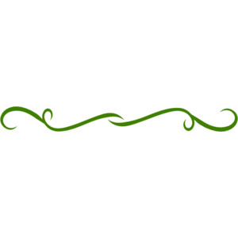

**Community Love Light Tree   
Dedication Ceremony…**

A Dedication Ceremony for the Community Love Light Tree   
will be held:

**@ 6pm Sunday, December 2rd   
at State Street Park   
Delmar, De.\****Refreshments will be served at the park.*

The names of those who have been honored by a light dedication will be displayed at the dedication ceremony.

Rain Date Saturday, December 9th



**Community**

**Love Light Tree**

ORDER FORM SIDE 1

Use this order form to   
place your **Love Light** order by the end of the day on November 18, 2018

*Orders may be placed after this date, however recognition of Honoree(s) cannot be guaranteed in time for the dedication ceremony.

This side of the order form is for information about you.

Please print legibly.

**Donor Information:**

Your Name

Phone *(if we have questions about your order)*

Address

City, State, Zip

Receipt Needed for tax purposes?

Yes No

*Please complete the other side of this form with information about the lights you wish to dedicate.*



**Thank you   
for your support!**

**Community**

**Love**

**Light**

**Tree**